Open Arduino IDE and Connect Arduino to computer.

Open File > Examples > 11. ArduinoISP > ArduinoISP

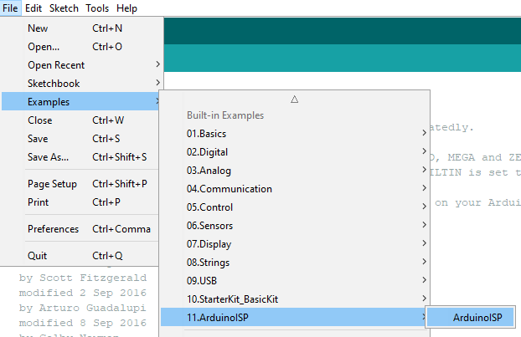

Choose Board : Arduino Uno and Port COM

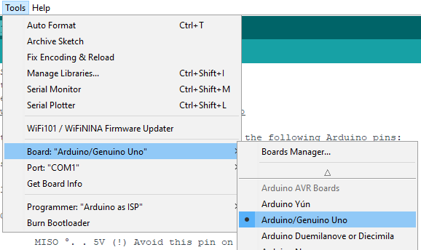

Upload to Arduino Uno

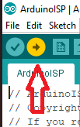

After upload done

**Change Board : Arduino Mega 2560 and Processor : ATmega2560**

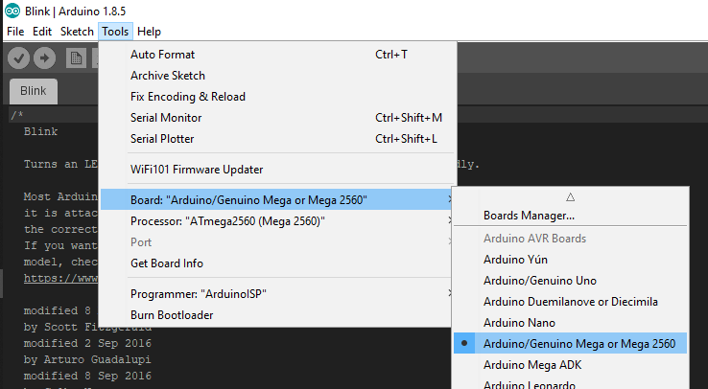

We use pin 10,11,12,13 (SS,MOSI,MISO,CLK) on Arduino Uno

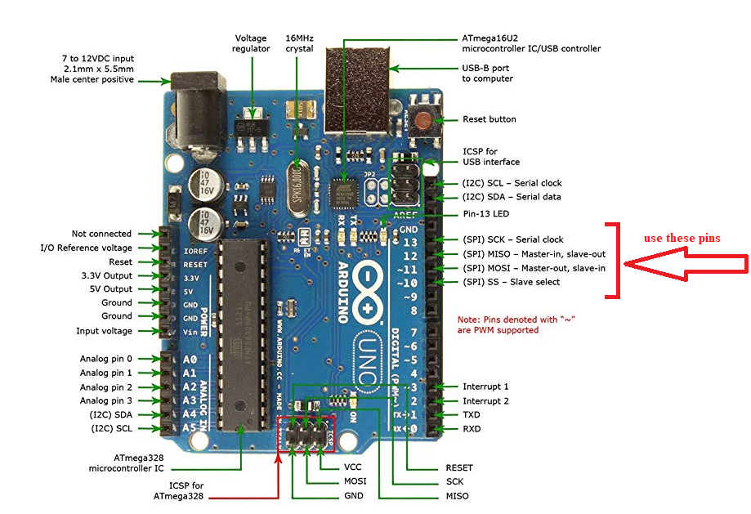

And connect to pins **(ISP Port)** on the Sensor Node

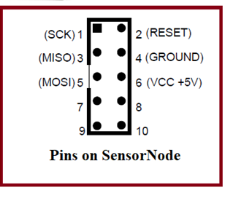

*Connect pin on Arduino Uno to Sensor Node*

**MOSI ( pin 11 ) > MOSI**

**MISO ( pin12 ) > MISO**

**SCK ( pin 13 ) > SCK**

**SS ( pin 10 ) > RESET**

**VCC ( 5V ) > VCC**

**GND > GND**

**Choose Board : Arduino Mega 2560 and Processor : ATmega2560**



**Connect Arduino to computer**

**Choose Programmer : “Arduino as ISP” and Port COM**

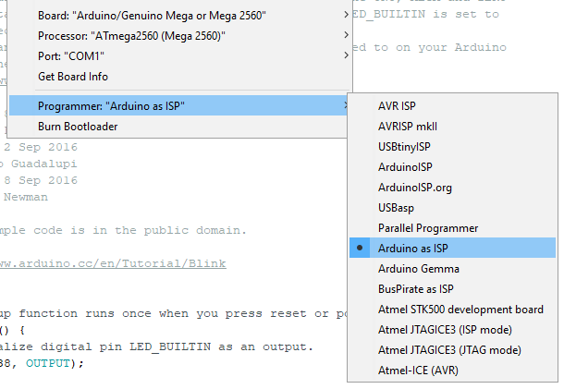

**Then click Burn Bootloader for ATmega2560 on Sensor Node.**

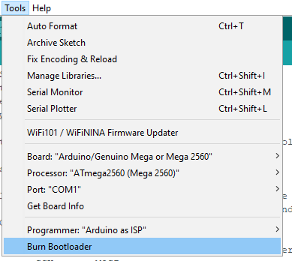

**Wait about 30 seconds to finish**

**Then, Open Aruidno IDE and open (code).ino file (updated code).**

**You must remove ATMega328P on Arduino UNO,**

**be careful, foot of Atmega328 can be broken.**

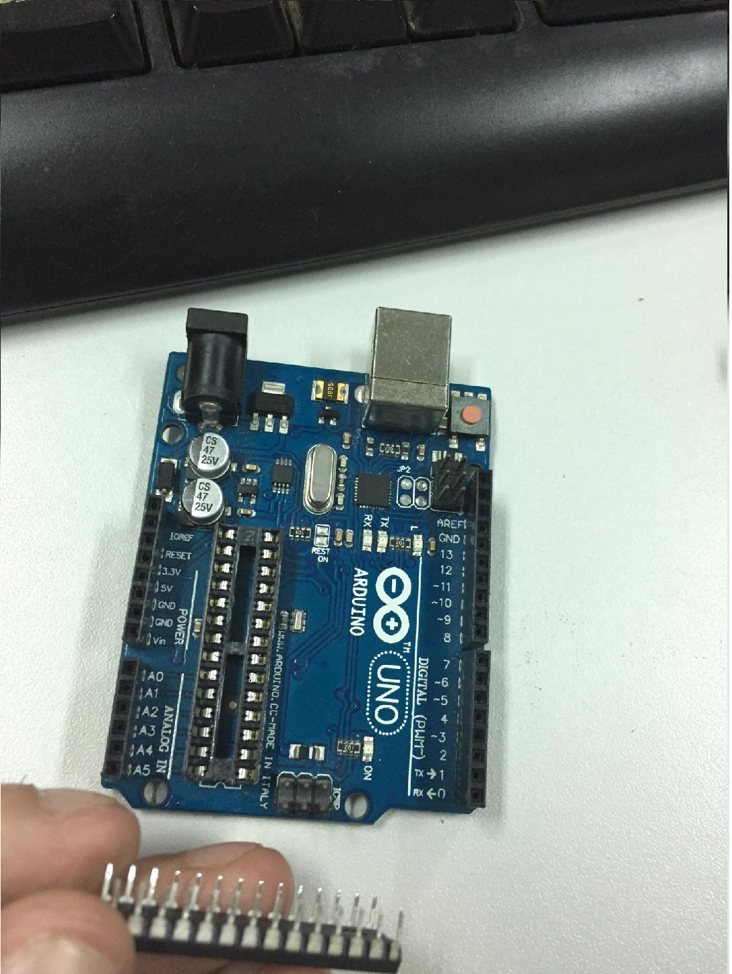

**We use the this Arduino Board without Atmega328P**

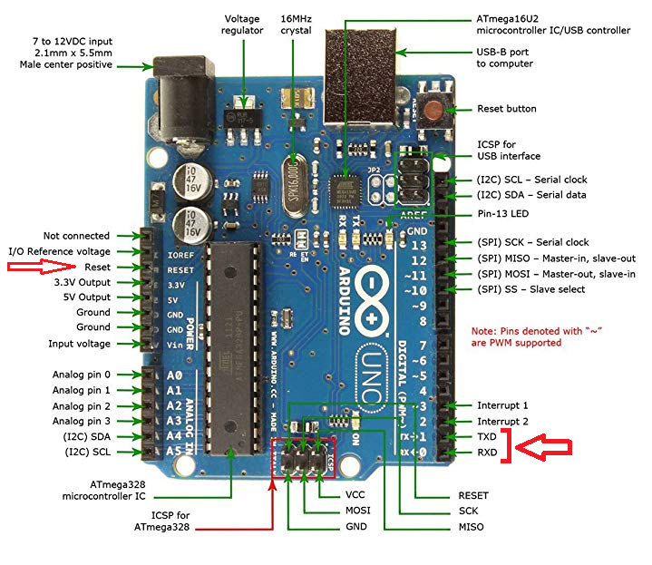

**Connect UART pins to SensorNODE. Look 3 pins below the ISP Port.**

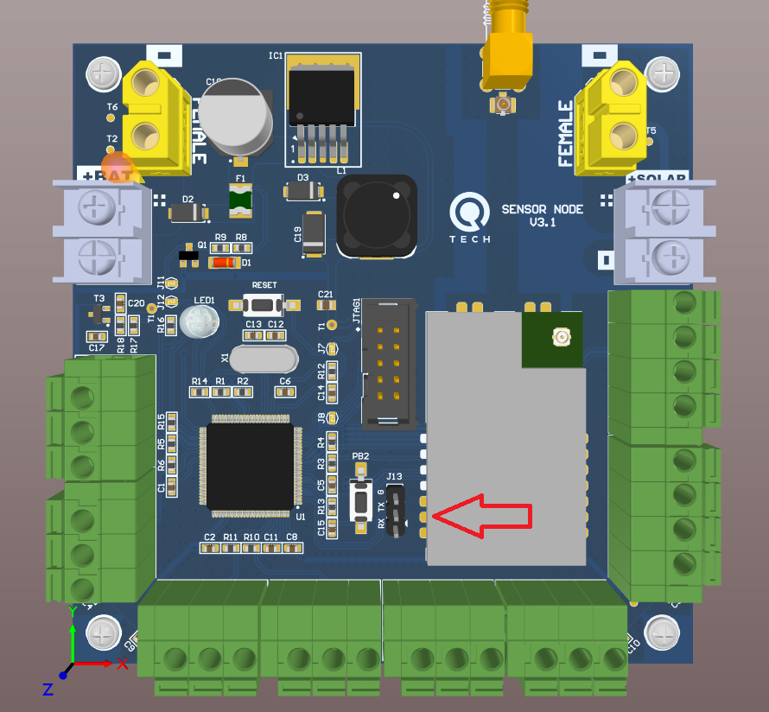

**TX > RX**

**RX > TX**

**GND > GND**

**RESET > RESET (on ISP Port)**

**5V > 5V (on ISP Port)**

**Then Upload code to ATMega2560 on SensorNode**

